Redevelopment of Uhuru Gardens in Efforts to Safeguard Kenya’s Green Spaces
Great progress has been made by Kenya in sustainable development, restoration, and preservation of its biodiversity. The ongoing redevelopment of Uhuru Gardens into a modern people's park is part of the Government’s efforts in ensuring the country’s green spaces are well protected and restored while preserving Kenya's rich history.
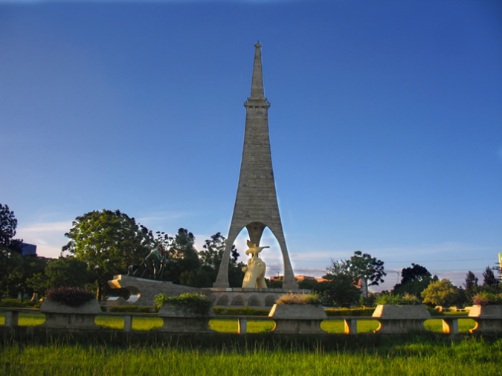
Located along Lang’ata Road, the park contains two monuments commemorating Kenya’s independence, and a Mugumo (fig) tree. The tree was declared a national monument in 1966, three years after the Kenyan flag was hoisted there on Independence Day, December 12, 1963. It was planted on the spot where the Union Jack (British flag) was brought down and Kenya’s national flag was first hoisted.
In addition to the historical significance, Uhuru Gardens attracts various events as a recreational park. It is popular as a rest area for families and friends, a must visit for schools and an events venue for corporate launches, concerts, weddings, film location just to name a few. The site has diverse flora and savannah woodland, attracting thousands of recreation seekers and nature lovers.
The garden had been closed for almost a year for renovations with plans of improving the park to have a wider variety of leisure activities, a government museum, shopping complex, business center, a hotel, a convention center and a sacred site. With 60% of the works complete, the facility hosted the 58th Jamhuri Day Celebrations on Sunday 12th December, 2021. During his speech, H.E President Uhuru Kenyatta announced that the park will be officially reopened in April 2022, accessible to the public free of charge.

